ICS3U: Installing and Setting Up
Here are step by step instructions for setting yourself up to use Dr. Java at home. Don’t worry if you’re not sure what a compiler or a package is. Just follow the instructions for now, and all will become clear in the fullness of time.
Note for Mac users: You can skip part 1 because the Mac OS comes with the Java compiler already installed. And you will have to modify the steps in part 2 a little.

1. Getting the Java Compiler
- Go to www.java.com

- Click on the Developers link at the bottom.
- Choose JDK Downloads.
- Click Download.
- Choose the latest JDK (at the time of writing, it’s “JDK 7u7”).
- Accept the license agreement and select your platform (Windows x64)
- Download, run the file, and follow the directions

2. Getting Dr. Java (if it’s not on your computer)
- Create a Dr. Java folder inside Program Files (go to My Computer, then C:, then Program Files)
- Download the Dr. Java file into that folder, either from the Moodle website or from www.drjava.org
- Right click the file, create a shortcut, and put it on your desktop

3. Getting The “hsa_new” Package
- In your Home folder (documents area), create a folder for ICS3U
- Download the file hsa_new.zip
- Uncompress the file to the folder you created (right click and choose Extract Files or Extract Here)

4. Managing Your Own Packages

- For each unit, you should create a package (folder) for exercises and another for the final assignment. These packages must be in the same folder as hsa_new, or your code will not run properly. It should look something like this…

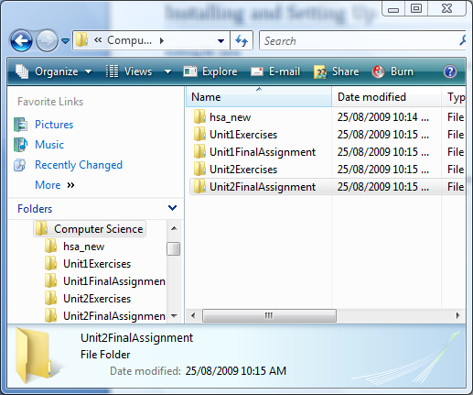

- When handing in your programs, you should right click the folder, and choose “Send to Compressed Folder”. This will create a single file that contains the entire folder. Then submit the entire zip file when handing in assignments.

